Name-Saiba Pathan
Rollno-09
Div-C
Lab 14
Title-Triggering Lambda from S3 to Update a DynamoDB Table
Objective:
Create a serverless workflow where uploading a file to an S3 bucket triggers a Lambda function,
which extracts metadata and stores it into a DynamoDB table.
Prerequisites:
• AWS Free Tier account
• IAM user with permissions to access S3, Lambda, and DynamoDB
Part A: Create a DynamoDB Table
1. Go to DynamoDB > Tables > Create Table
2. Table name: S3Uploads
3. Partition key: FileName (String)
4. Leave other settings as default
5. Click Create Table
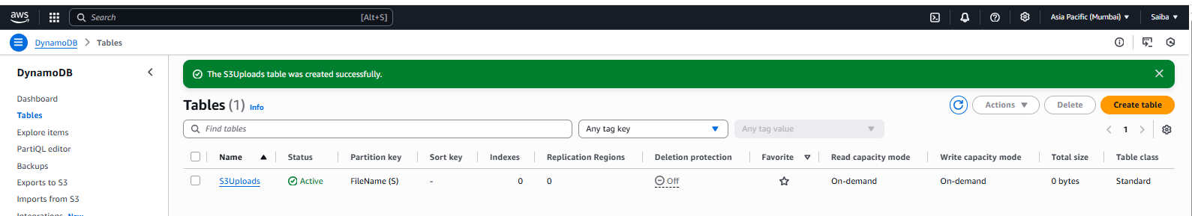
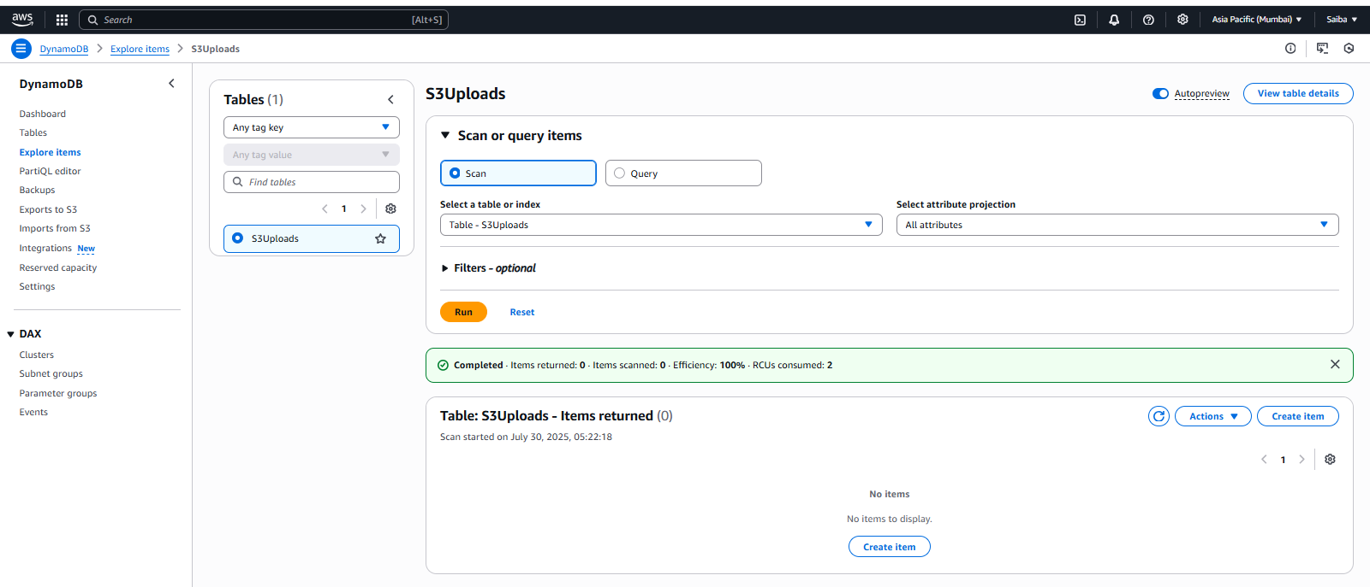

Part B: Create an S3 Bucket
1. Navigate to S3 > Create bucket
2. Bucket name: lambda-s3-dynamo-demo (must be globally unique)
3. Region: e.g., ap-south-1
4. Disable "Block all public access"
5. Click Create bucket
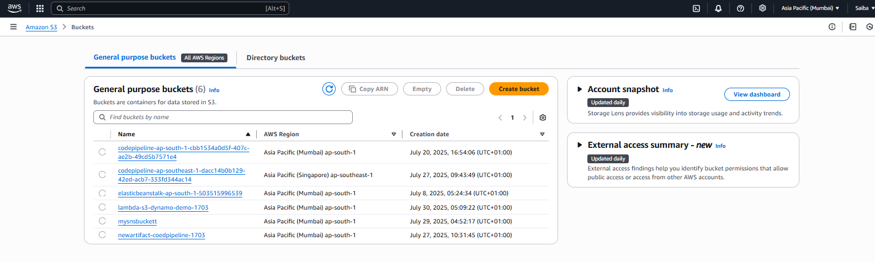
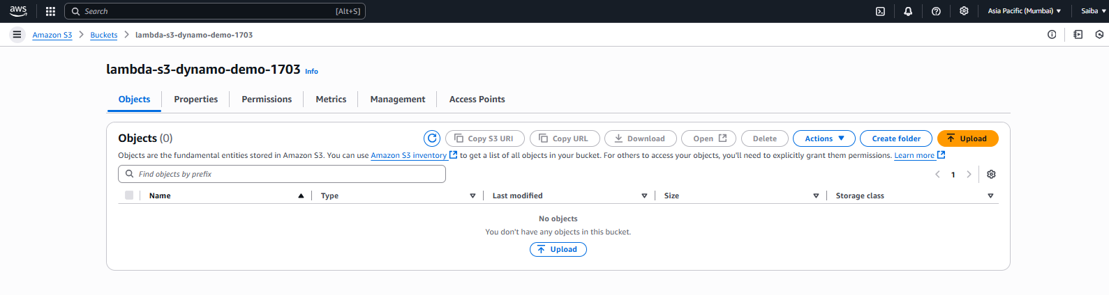

Part C: Create a Lambda Function
1. Go to Lambda > Create function
2. Name: S3ToDynamoDBLogger
3. Runtime: Python 3.10
4. Execution role:
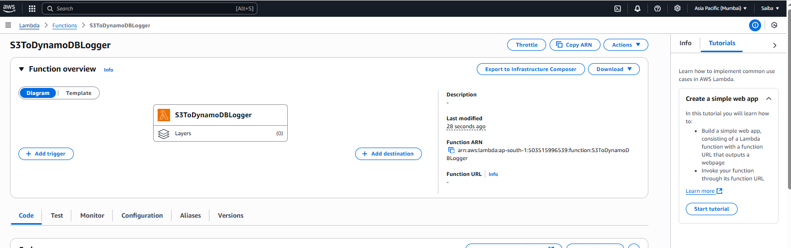

• Select "Create new role with basic Lambda permissions"
After creation, go to the IAM role and attach the following policies:
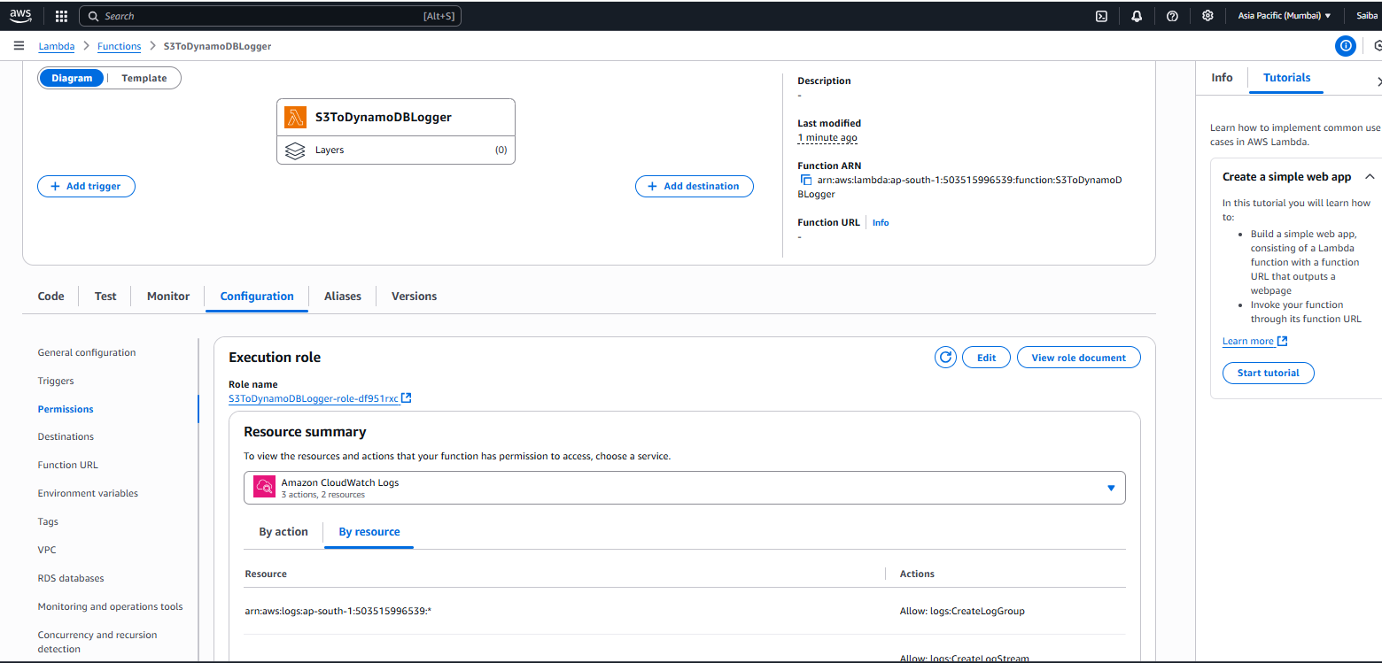

• AmazonS3ReadOnlyAccess
• AmazonDynamoDBFullAccess
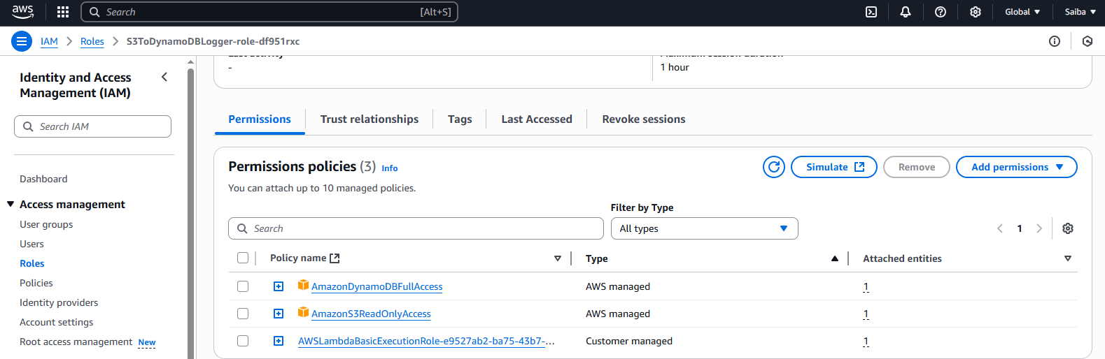

Part D: Add S3 Trigger to Lambda
1. Go to the Lambda function > Configuration > Triggers
2. Add trigger:
• Source: S3
• Bucket: lambda-s3-dynamo-demo
• Event type: PUT
3. Click Add
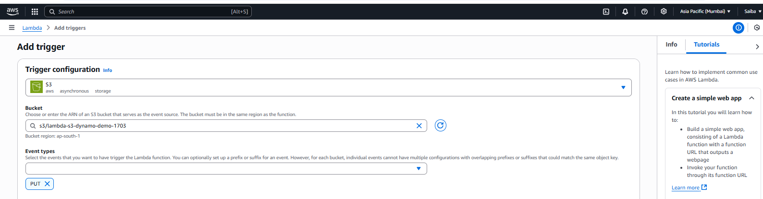
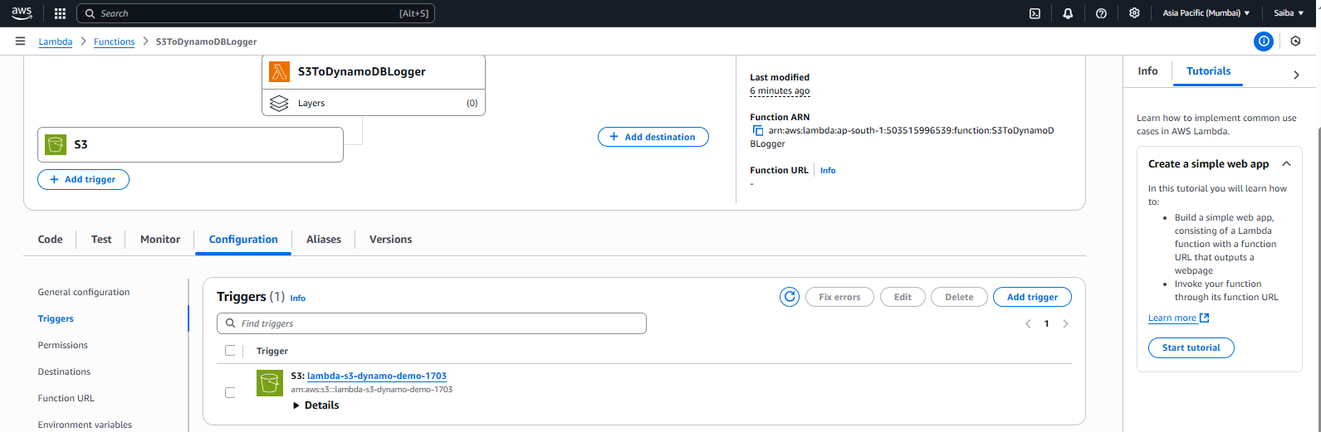

Part E: Lambda Function Code
1. Open Code section of the Lambda function
2. Replace the default code with the following:
'statusCode': 200,
'body': json.dumps(f"File '{file_key}' metadata inserted into
DynamoDB.")
}
3. Clicimport json
import boto3
import time
dynamodb = boto3.resource('dynamodb')
table = dynamodb.Table('S3Uploads')
def lambda_handler(event, context):
records = event.get('Records', [])
if not records:
return {"statusCode": 400, "body": "No records found."}
s3_info = records[0]['s3']
bucket = s3_info['bucket']['name']
file_key = s3_info['object']['key']
size = s3_info['object'].get('size', 0)
timestamp = int(time.time())
# Insert metadata into DynamoDB
table.put_item(
Item='FileName': file_key,
'Bucket': bucket,
'Size': size,
'Timestamp': timestamp
}
)
return {
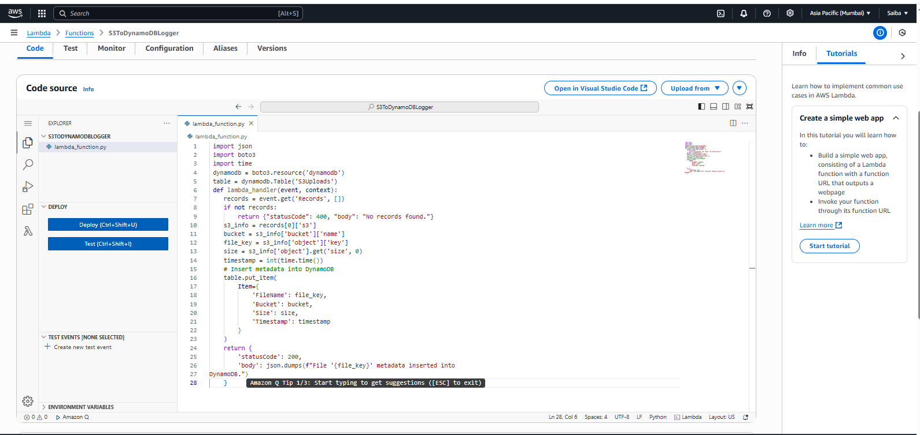

k Deploy to save and apply the changes
Part F: Test the Integration
1. Go to S3 > lambda-s3-dynamo-demo > Upload
2. Upload any file (e.g., sample.txt)
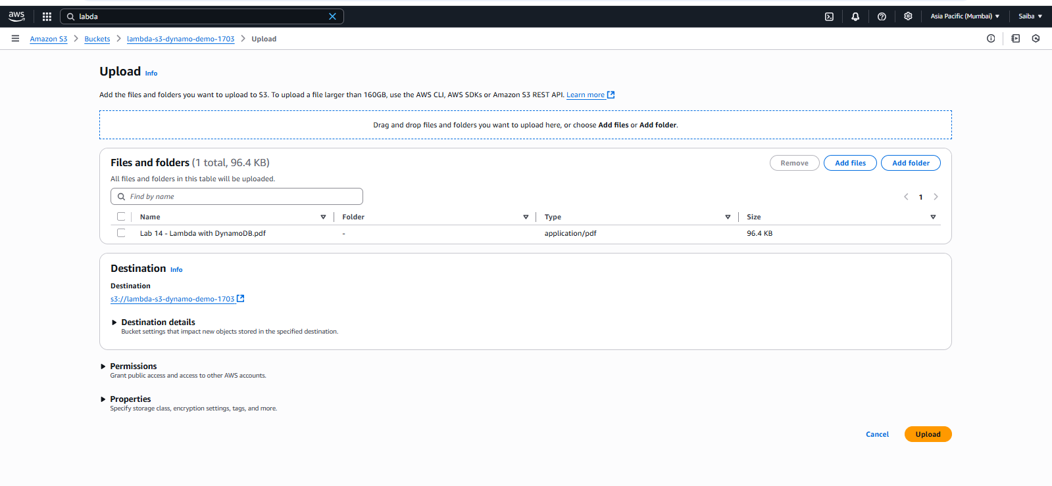

3. Wait a few seconds
4. Go to DynamoDB > Tables > S3Uploads > Explore Table Items
5. You should see a new record:
• FileName: sample.txt
• Bucket: lambda-s3-dynamo-demo
• Size: ...
• Timestamp: ...
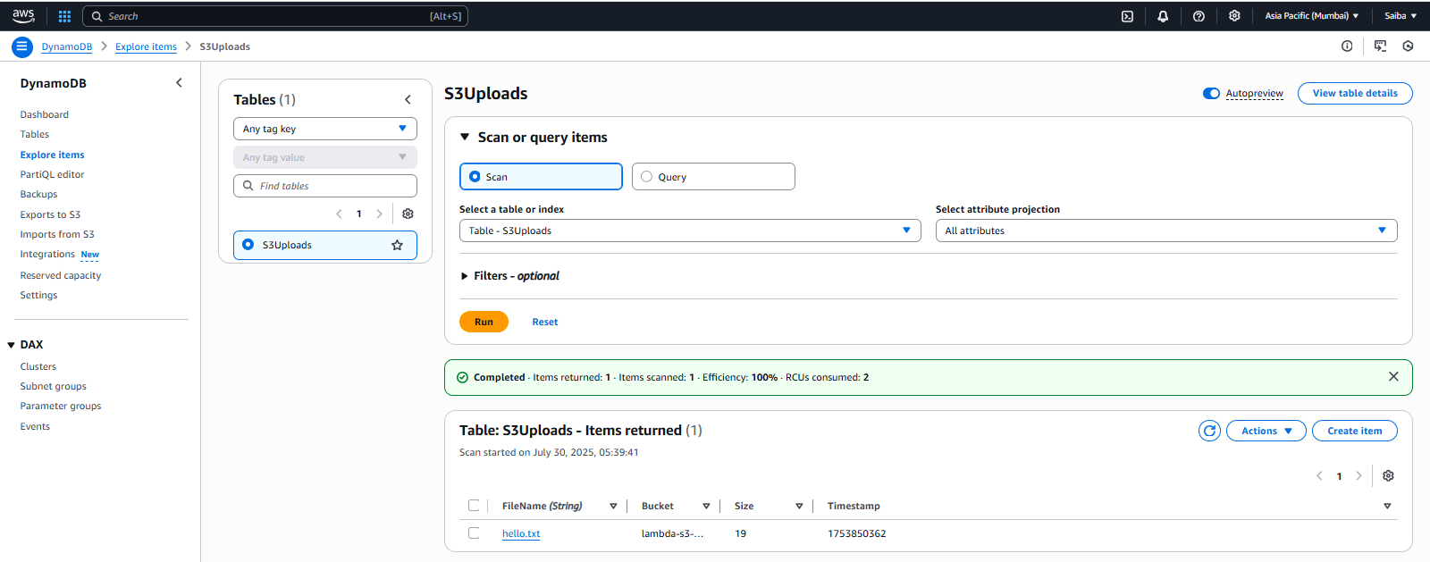
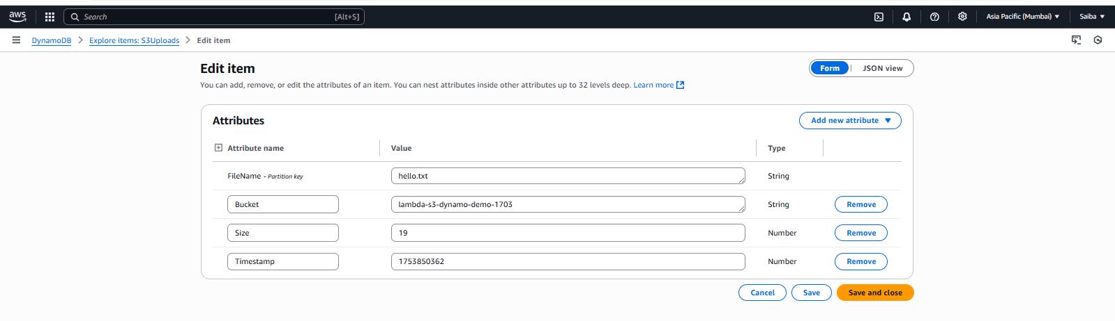

Part G: Cleanup (Optional)
• Delete Lambda function
• Delete DynamoDB table
• Delete S3 bucket
Student Assignment
• Extend Lambda to log file type or uploader IP (if available)
• Log the operation in CloudWatch
• Validate file types before inserting into DynamoDB

